**Day 4-HTML Worksheet (Style, Form)**

https://lh6.googleusercontent.com/pzfkpYzj_xNKuCIRaMdGOcJRGHimowNa5u7Ned4rI9rrL8AGediPxVgoTzYM65B3F7T2wKnzzs4NN42aMrsGf_ZZvSDkx9V2RHZ5SJ6YjjldEA7E9x9SwUSXZmLWBKV9rfHuNRbkG3bXpFexSg

**Refresh yesterday’s Class-10 Minutes**

1. Match the following

|  |  |
| --- | --- |
| 1. <td> tag is used for | 1. create table heading |
| 1. <tr> tag is used for | 1. create data cells |
| 1. <th> tag is used for | 1. create table rows |

1. Cell-padding is used to:-
2. define the width of the border
3. represent the distance between cell borders and the content within a cell
4. merge two or more columns into a single column
5. merge two or more rows
6. Which attribute is used to set background color for whole table or just for one cell
7. bg-color=”blue”
8. bgcolor=”blue”
9. background=”blue”
10. background-color=”blue”

**Activity -30 Minutes**

<!DOCTYPE html>

<html>

<body style="background-color:blue;">

<h1 style="color:blue;">This is a heading</h1>  
<p style="color:red;">This is a paragraph.</p>

< p>I am normal</p>

<p style="color:red;">I am red.</p>

<p style="color:blue;">I am blue.</p>

<p style="font-size:36px;">I am big.</p>

<h1 style="font-size:300%;">This is a heading</h1>  
<p style="font-size:160%;">This is a paragraph.</p>

<h1 style="font-family:verdana;">This is a heading</h1>  
<p style="font-family:courier;">This is a paragraph.</p>

<h1 style="text-align:center;">Centered Heading</h1>  
<p style="text-align:center;">Centered paragraph.</p>

<p style="color:green; font-size:20px;">This is thick and green</p>

</body >

</html>

## Activity -1 Hour

<!DOCTYPE html>

<html>

<body>

<form>

<fieldset>

<legend>Personal information:</legend>

First name:<br>

<input type="text" name="firstname" value="Mickey">

<br>

Last name:<br>

<input type="text" name="lastname" value="Mouse">

<br><br>

<input type="submit" value="Submit">

</fieldset>

</form>

</body>

</html>

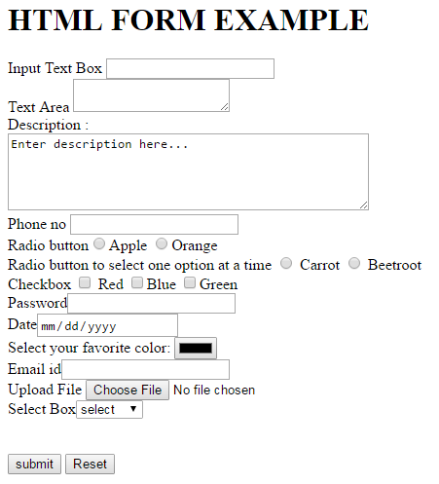

<html>

<body >

<h1 >HTML FORM EXAMPLE</h1>

<form>

Input Text Box <input type="text" name="txtname"><br>

Text Area <textarea name="txtadress"></textarea><br>

Description : <br />

<textarea rows="5" cols="50" name="description">

Enter description here...

</textarea>

<br>

Phone no

<input type="text" name="txtphoneno"><br>

Radio button<input type="radio" name=" fruit" value="Apple" id="r1">Apple

<input type="radio" name="fruit" value="Orange" id="r2">Orange <br>

Radio button to select one option at a time

<input type="radio" name="vegetable" value="carrot"> Carrot

<input type="radio" name="vegetable" value="beetroot"> Beetroot <br>

Checkbox

<input type="checkbox"name="q1"value="Red"id="ch1"> Red

<input type="checkbox" name="q2" value="Blue"id="ch2">Blue

<input type="checkbox" name="q3" value="Green"id="ch3">Green <br>

Password<input type="password"name="txtpassword"> <br>

Date<input type="date" name="txtdate"> <br>

Select your favorite color: <input type="color" name="favcolor"> <br>

Email id<input type="email" name="textusername"> <br>

Upload File <input type="file" name="fileupload" accept="image/*" /><br>

Select Box<select name="txtcountry">

<option value="select">select</option>

<option value="usa">USA</option>

<option value="uk">UK</option>

<option value="canada">Canada</option>

</select><br><br><br>

<input type="submit" name="button" value="submit">

<input name="reset" type="reset">

</form>

</body>

</html>